Fluffy Pancakes Recipe ( makes 2-3 servings, you can easily double the recipe) :
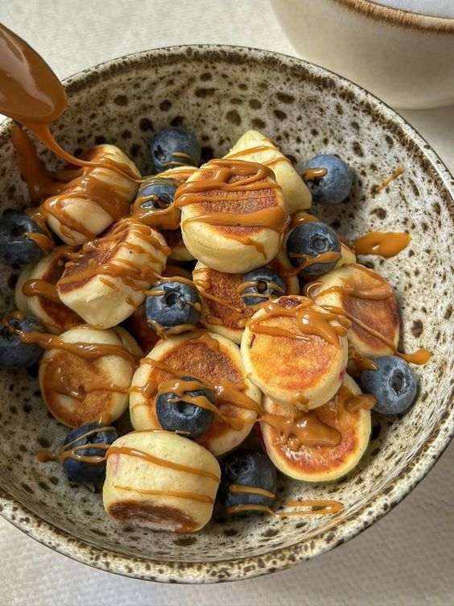
- 125 gr All Purpose Flour (3/4 cup + 1 tbsp)
- 1/4 tsp Baking Soda - 1/2 tsp Baking Powder
- Pinch of Salt - 1 Egg
- 25 gr melted Butter ( 2 tbsp)
- 150 gr Buttermilk (1/2 cup + 4 tbsp) OR milk + 1/4 tsp vinegar/lemon juice)
- 30 gr Sugar ( 2 1/2 tbsp)

